Create a folder on your desktop, and then right click on it.

Click on

This window pops up. Enter the URL in the first field

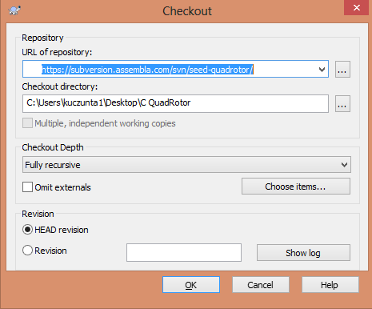

You will need an account from assembla.com, create an account/organization for free. It is free for 3 people. Fortunately we only have a group of 3 people. Upon hitting OK on the window above, there will be a login window that appears. Login using your assembla.com username and password.

Hit ok and things should disappear.

When you start Visual studio with the software installed, this window pops up. Enter the location of the arduino folder in the first field. The second field you need to enter the location of the folder you created above. And then add \trunk\Quadrotor to the end of the folder directory. These folders should have been created by the repository (svn stuff)

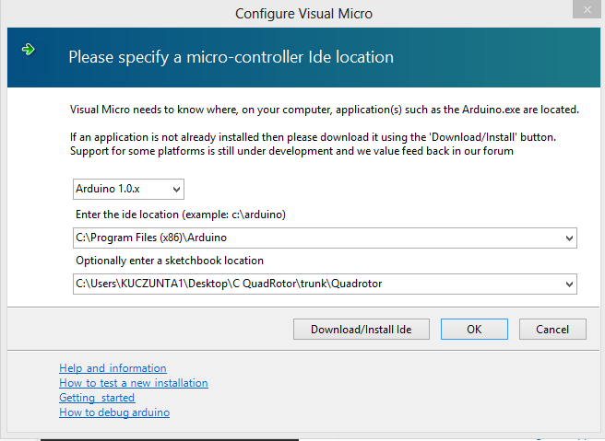

Close Visual Studio, and open the .sln file that is in the second directory with visual studio.

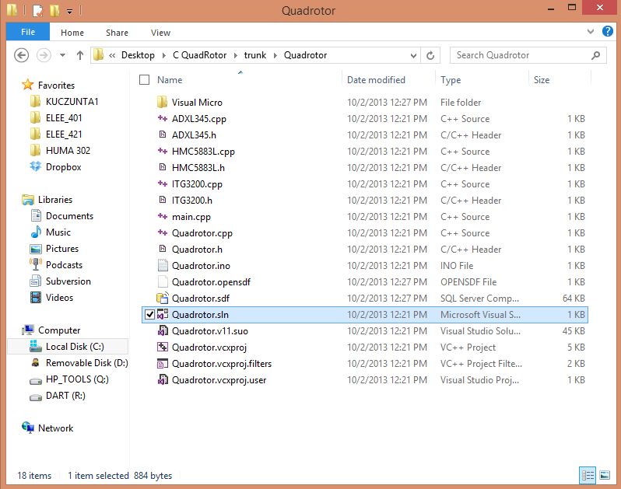

This is just to test to see if everything is working.

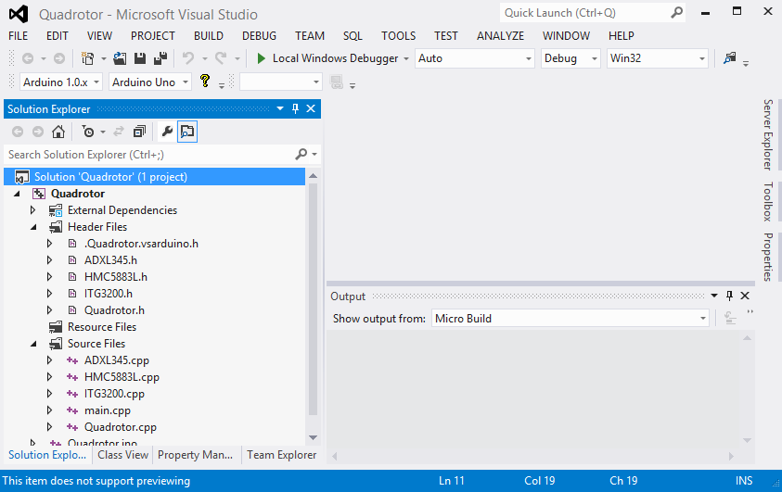

The window should look something like this.

You need to tell VS which board we are using. Go to Tools >> Visual Micro Arduino… (first item) >> Boards >> Arduino Mega 2560

Right click on the solution ‘Quadrotor’ (1 project) >> properties